FAZAIA BILQUIS COLLEGE OF EDUCATION FOR
WOMEN PAF NUR KHAN, RWP

Parallel Distributed Computing (LAB)
Lab 7 Tasks
Submitted to
Ma’am Iffat

Submitted by
Javeria Fazal
BSCS 7th B
F21-62

Task 1
Write a C# console program that performs a sequential prefix sum (scan) of an integer array without using TPL.
The program should take a predefined integer array and compute the prefix sum sequentially.
1. Initialize an array of at least 8–10 elements.
2. Use a simple for loop to calculate the cumulative (prefix) sum.
3. Print both the input and output arrays for verification.
4. Observe the sequential flow of execution
- Source Code with Output Screenshot:
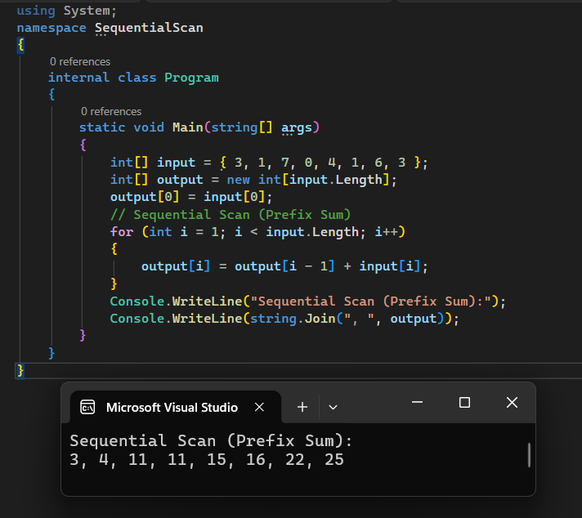
Figure 1: Source Code with Output
Task 2
Write a C# program that performs a parallel inclusive scan on a large integer array. Each element data[i] should become the sum of all previous elements up to index i.
- Use Parallel.For to perform computations in parallel and measure total execution time using Stopwatch.
- Source Code with Output Screenshot:
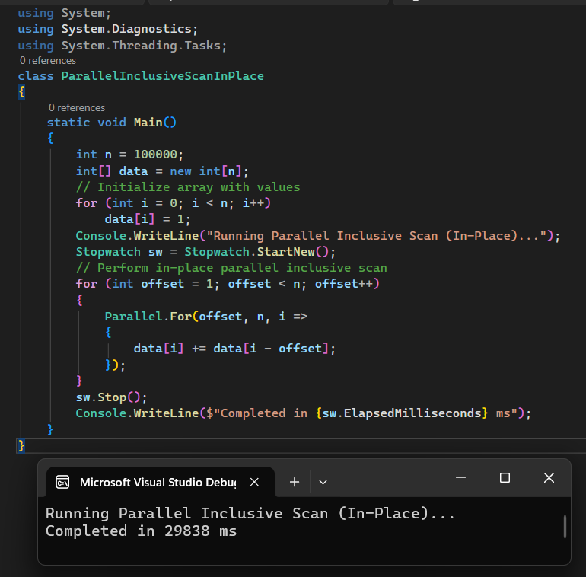
Figure 2: Source Code with Output

Task 3
- You are required to implement a C# console program that uses four threads to generate approximately 70% CPU load for 30 seconds on a dual-core system.
- Each thread should perform continuous mathematical computations (e.g., square root operations) to keep the CPU busy, combined with short pauses to reduce full utilization.
- The goal is to visualize how parallel execution distributes workload across CP cores and how thread coordination affects overall utilization.
- Source Code with Output Screenshot:
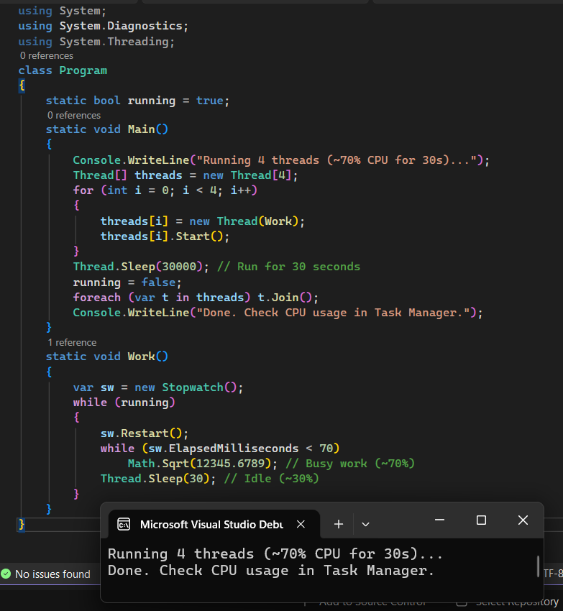
Figure 3: Source Code with Output

